Requirement Tracker

Table of Contents

Purpose 3

Requirements 3

Use Case 4

High level class diagram 5

Database Design 6

Activity Diagram 9

Add/Modify Requirements 9

Add/Modify Status 10

Add/Modify Interviews 11

Version 12

# Purpose

Web application for tracking potential opportunities for trainees in the market. This allows for easier accumulation of data and access. This will be created using a central repository and populated with potential opportunities offered by the Multivision marketing team.

# Requirements

* Standalone Web Application built using Spring MVC
* User security using Spring Security Framework
* Users and Requirement History displayed
* Data persisted in Oracle DB using Hibernate
* Users can CRU personal status, can CR requirements and Tech/Skills
* Supervisors can RD all requirements
* Tables can be sortable
* Requirement Analytics
  + Requirement/Date Range
  + Vendor Interviews/Date Range
  + Client Interviews/Date Range
  + Total Requirements
  + Total Vendor Interviews
  + Total Client Interviews

# Use Case

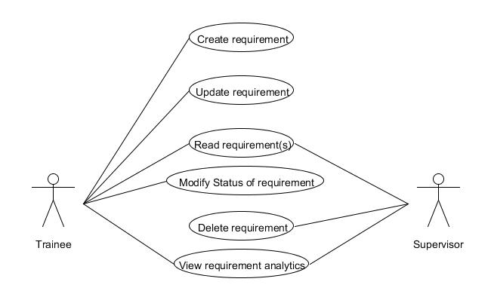

# High level class diagram

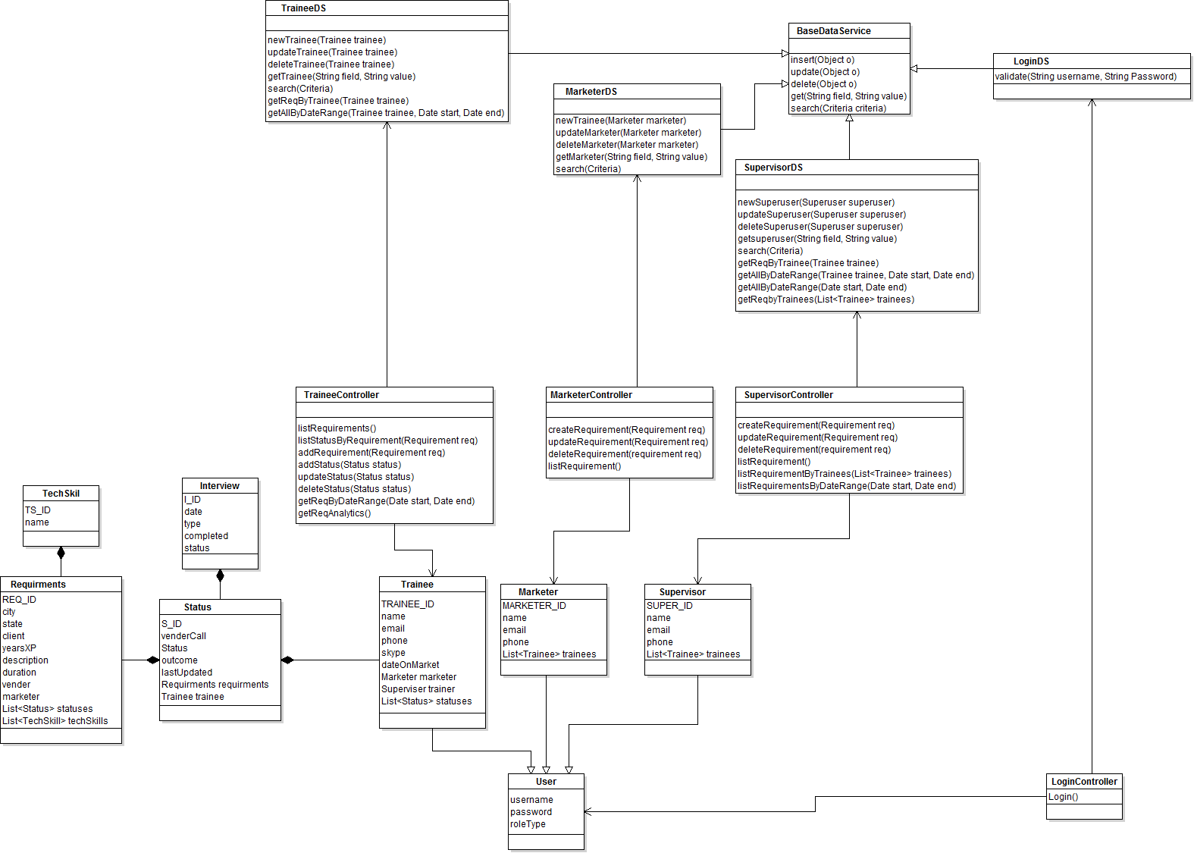

# Database Design

|  |  |
| --- | --- |
| **User** | |
| **Column** | **Type** |
| U_ID**<pk>** | Number |
| Username | Varchar |
| Password | Varchar |
| RoleType | Varchar |

|  |  |
| --- | --- |
| **Supervisor** | |
| **Column** | **Type** |
| Super_ID**<pk>** | Number |
| name | Varchar |
| Email | Varchar |
| Phone | Varchar |

|  |  |
| --- | --- |
| **Trainee** | |
| **Column** | **Type** |
| T_ID**<pk>** | Number |
| Name | Varchar |
| Email | Varchar |
| Phone | Varchar |
| Skype | Varchar |
| DateOnMarket | Date |
| M_ID**<fk>** | Number |
| Super_ID**<fk>** | Number |

|  |  |
| --- | --- |
| **Marketer** | |
| **Column** | **Type** |
| M_ID**<pk>** | Number |
| Name | Varchar |
| Email | Varchar |
| Phone | Varchar |

|  |  |
| --- | --- |
| **Status** | |
| **Column** | **Type** |
| S_ID**<pk>** | Number |
| VenderCall | Varchar |
| Status | Varchar |
| Outcome | Varchar |
| LastUpdated | date |

|  |  |
| --- | --- |
| **Interview** | |
| **Column** | **Type** |
| I_ID**<pk>** | Varchar |
| Date | Date |
| Type | Varchar |
| Completed | Boolean |
| S_ID<fk> | Varchar |

|  |  |
| --- | --- |
| **Requirements** | |
| **Column** | **Type** |
| Req_ID**<pk>** | Number |
| City | Varchar |
| State | Varchar |
| Client | Varchar |
| Experience (years) | Number |
| Description | Varchar |
| Duration = (years) | Number |
| Vender | Varchar |
| M_ID **<fk>** | Number |

|  |  |
| --- | --- |
| **Req_Ts** | |
| **Column** | **Type** |
| Req_ID**<fk>** | Number |
| Ts_ID**<fk>** | Number |

|  |  |
| --- | --- |
| **Technical Skills** | |
| **Column** | **Type** |
| Ts_ID**<pk>** | Varchar |
| Name | Varchar |

# Activity Diagram

## Add/Modify Requirements

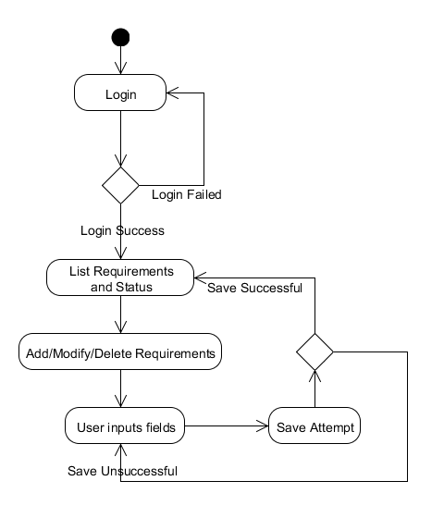

## Add/Modify Status

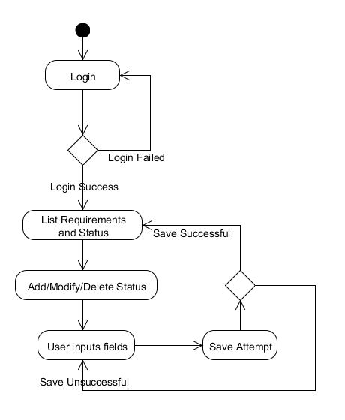

## Add/Modify Interviews

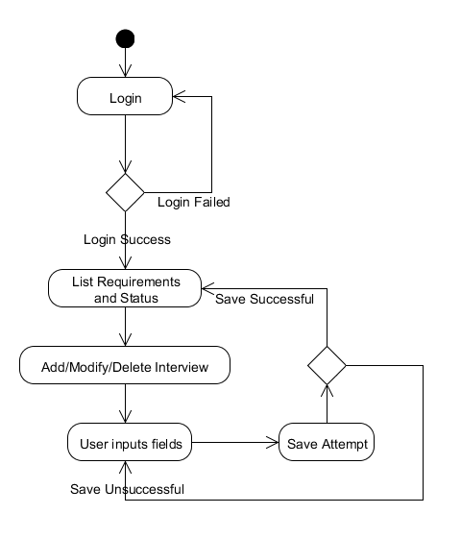

# Version

|  |  |  |
| --- | --- | --- |
| Creator | Version | Date |
| Chris | v.1 | 4/21/2014 |